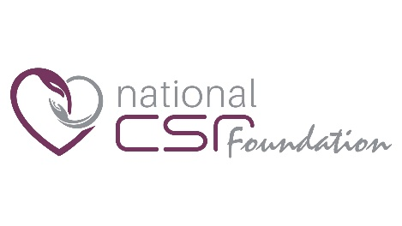
National CSR Foundation
6th Floor, Garden Tower, La Poudrière St,
Port-Louis
Tel: 4055152/4055169
Email: info@ncsrfoundation.org

REGISTRATION OF POTENTIAL SUPPLIERS
APPLICATION FORM
- Name of Supplier: ……………………………………………………………………………………………………………..
(Company/Individual)

- Address: ……………………………………………………………………………………………………………………………

…………………………………………………………………………………………………………………………………………..

- Phone No.: …………………………………………………………………………………………………………………………

- Fax No.: ………………………………………………………………………………………………………………………………

- E-mail address: …………………………………………………………………………………………………………………..

- Name of Contact Person: ……………………………………………………………………………………………………

- Certificate of incorporation: ……………………………………………………………………………………………….

- Name of Directors: …………………………………………………………………………………………………………….

……………………………………………………………………………………………………………………………………………

……………………………………………………………………………………………………………………………………………

- Tyre of Business: ………………………………………………………………………………………………………………..

- Business Registration Number: …………………………………………………………………………………………..

- VAT Registration Number (if applicable): ……………………………………………………………………………

- Tax Account Number: …………………………………………………………………………………………………………

- Tax Status (Tax clearance certificate for last financial year): ………………………………………………

……………………………………………………………………………………………………………………………………………

- Whether debarred by competent authority to participate in any binding exercise: Yes/No

If yes, specify the period …………………………………………………………………………………………………..

- Whether convicted by any court of law for fraudulent/corrupt/collusive/coercive practice:
Yes/No

I/ We hereby apply for registration to supply the goods and services mentioned below
Item No. | Description

The attention of the applicants is hereby drawn to the fact that the National CSR Foundation has no contractual obligation towards them and this shall not entitle them to become providers of goods and services to the National CSR Foundation.

Name: ………………………………………………………………… Signature: ……………………………………………………

Date: …………………………………………….. Seal: …………………………………………………………

