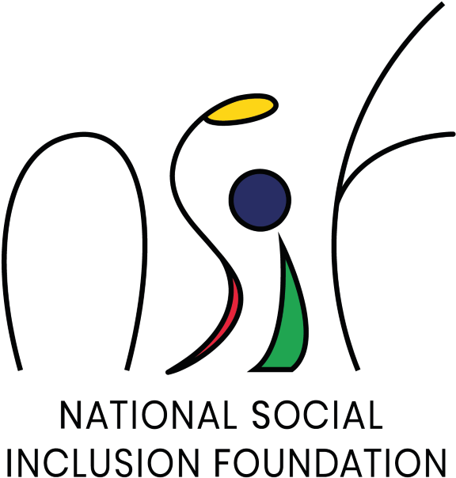

Addendum on Proposals for Consultancy Services

Consultancy Services for the Digital Transformation and Project Management and Quality Review Services during implementation phase at National Social Inclusion Foundation issued on 8 August 2020.
Procurement reference No. NSIF/OAB/2/20

The National Social Inclusion Foundation (NSIF) hereby inform prospective bidders that it is amending
(i) Clause 2 of section 2 - Instruction to bidders, so that sub – clause 2.1 and 2.2 will now read as under
2.1 – consultants may request a clarification of any of the RFP documents up to the numbers of days indicated in the Data Sheet before the proposal submission date. Any request for clarification must be sent in writing, or by standard electronic means to the client’s address indicated in the Data Sheet. The client will respond in writing, or by standard electronic means and will display the response on its website.
All requests for clarifications should be sent to the NSIF 14 days before the proposal submission date.
It is the responsibility of prospective bidders to consult the website of the NSIF as regards Clarification and amendments of RFP documents.
2.2 To add after the word proposals any amendments to the RFP documents may also be published in the local press.
(ii) Clause 2.1 - Instructions to Consultants- Data sheet
Clarifications may be requested not later than 14 days before the submission date.
(iii) Clause 4.5 - Instructions to Consultants- Data sheet
Proposals must be submitted not later than the following date and time: 14th October 2020 at 14 hrs 30 at latest.

