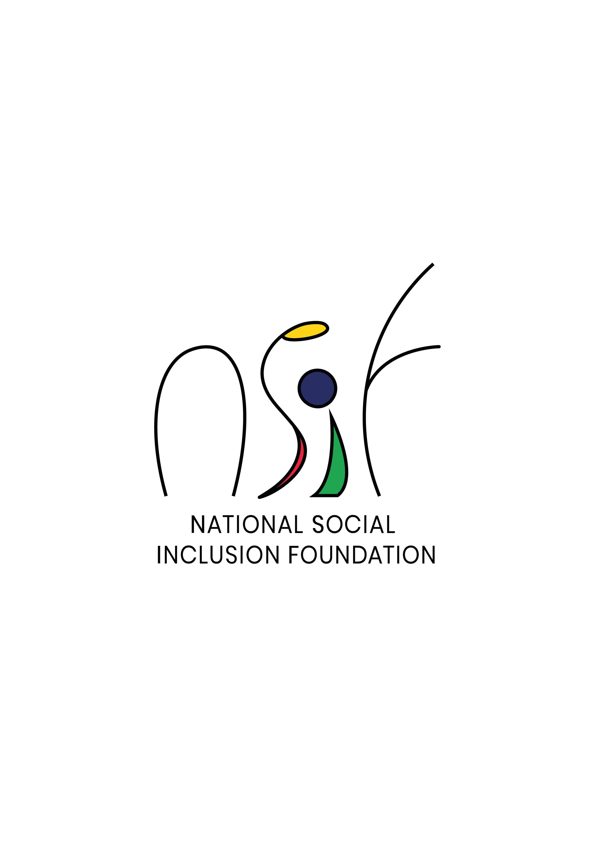

**Restricted Call for Proposals – Small Scale Initiatives 2022**

**Guidelines for Application of Funds**

The National Social Inclusion Foundation (NSIF) is the central body to receive and allocate public funds to NGOs.

The mission of the Foundation is **“to empower and improve the wellbeing of people living in conditions of poverty and vulnerability through impactful and sustainable stakeholder partnerships”.**

The NSIF adopts **a rights-based approach and a social investment model** to guide its funding decisions. This means:

* Committing to the realisation of basic human rights as a means of addressing the multidimensional nature of poverty and vulnerability
* Funding for results and outcomes by investing in basic services, programmes and projects that demonstrate improved social outcomes, especially for those who are most in need
* Ensuring accountability and transparency in the use of funds with monitoring, evaluation and learning built in the funding process.

**Supporting Small-Scale Initiatives**

Small actions at the local community level can have big positive impact. The Foundation seeks to fund **micro and small-scale projects**,under its Funding Instrument F4: Supporting Small-Scale Initiatives, with the view to improving the wellbeing of poor and vulnerable groups/communities and promoting social inclusion.

**Eligibility**

NGOs/NPOs meeting the following criteria are eligible to apply for funding.

1. The applicant must be duly registered with the NSIF.
2. The applicant must **not** be a current recipient of any funding from the NSIF for the financial year 2022-2023.
3. Collaborative partnerships of NGOs may apply provided the lead applicant satisfies the above criteria. The lead organisation will bear accountability for stewardship of funds awarded by the NSIF.

**Funding Conditions**

1. Application for funding shall be for a maximum amount of Rs500,000.
2. Where an NGO demonstrates adequate technical, financial, management and governance capabilities to implement a project of higher value, application for funding for up to a maximum amount of Rs1m may be considered. The application must be supported by evidence of relevant track record for the last two years.
3. The total amountof funding to be awarded to an NGO will in any circumstances be based on its average annual budget for the last two years.
4. Approved funding will be for a maximum of 12 months.
5. The Foundation will only fund expenditures directly incurred in the delivery of projects.
6. Management and administrative costs must not exceed 15% of the total project cost.
7. The Foundation will **not** fund:

* Items used by an organisation from its existing stock
* Participation to conferences and workshops overseas
* Construction of buildings
* Purchase of vehicles
* Provision of scholarships
* Consultancy/Project write up fees

**Priority Areas**

Projects should address the following ten priority areas of intervention:

* Socio-economic development as a means of Poverty Alleviation
* Educational support and training
* Social housing
* Supporting people with disabilities
* Dealing with health problems
* Family protection including gender-based violence
* Leisure and sports
* Environment and sustainable development
* Peace and nation-building
* Road safety and security

**Target Beneficiaries**

* Individuals and families eligible under the Social Register of Mauritius
* Individuals and families recognised as vulnerable groups as defined below:
  + Children and/or adults living below the relative poverty line, as defined by Statistics Mauritius
  + Children and/or adults with disabilities and/or suffering from a severe disease
  + Abused children and/or adults
  + Neglected/abandoned children and orphans and children in alternative care
  + Street children, including children who:
    - live and sleep in the street; and
    - are in the street during the day but sleep in the family home;
  + Teenage mothers and children in single parent families
  + Children with parents in prison
  + Children suffering from family conflict
  + Children engaging in violent or delinquent behaviour and children in conflict with the law
  + Out-of-school and illiterate children
  + Illiterate adults
  + Children and/or adults suffering from substance abuse
  + Vulnerable elderly
  + And such other stigmatised, discriminated, most-at-risks group as may be determined by the Foundation

**Assessment**

The assessment of project proposals shall be made according to the criteria set out below. Applicants may be asked to provide additional information as required during the assessment process.

|  |
| --- |
| 1. **Relevance**   Project:   * 1. Aligns to the priority areas of the Foundation and beneficiaries appropriately targeted   2. Clearly identifies and addresses particular needs and problems of target group |
| 1. **Effectiveness**     1. Activities well defined with realistic action plan and timeframes    2. Planned activities likely to achieve project objectives and expected results |
| 1. **Efficiency**    1. Planned use of resources and budgeted items reflect proposed activities    2. Budgeted expenditures justified, appropriate and realistically estimated |
| 1. **Impact**   Project:   * 1. Likely to have a tangible impact on target group   2. Likely to have multiplier effects in the community and society |
| 1. **Sustainability**    1. Organisation has adequate capabilities to implement project    2. Positive outcomes sustainable    3. Collaborative partnerships explored |

**Funding Contract Agreement, Monitoring and Disbursement of Funds**

Funded NGOs will be required to sign a Funding Contract Agreement (FCA). The FCA is a legally binding document setting out the general terms and conditions of funding.

The Foundation will monitor the implementation of all approved projects. This will include:

* Field visits carried out by NSIF Programme Officers
* Submission of periodic activities and financial reports by the funded NGO

Disbursement of funds will be made in instalments. A first instalment is to be paid at signature of the FCA and subsequent instalments will be disbursed upon satisfactory monitoring performance.

**Application**

* Applications should be made on the prescribed Application Form downloadable from the Foundation’s website [www.nsif.mu](http://www.nsif.mu)
* All applications must be submitted by email on the following address [applications@nsif.mu](mailto:applications@nsif.mu)
* The deadline for submission of applications is 15:00 on Friday 9 September 2022.
* Late and/or incomplete applications and applications not submitted on the prescribed Application Form will not be considered.

**Information and Guidance**

For any further information and guidance, please contact the NSIF Help Desk at [info@nsif.mu](mailto:info@nsif.mu) or 2602406.

2602406

[info@nsif.mu](mailto:info@nsif.mu)

www.nsif.mu

National Social Inclusion Foundation

6th Floor, Garden Tower

La Poudriere Street

Port Louis

