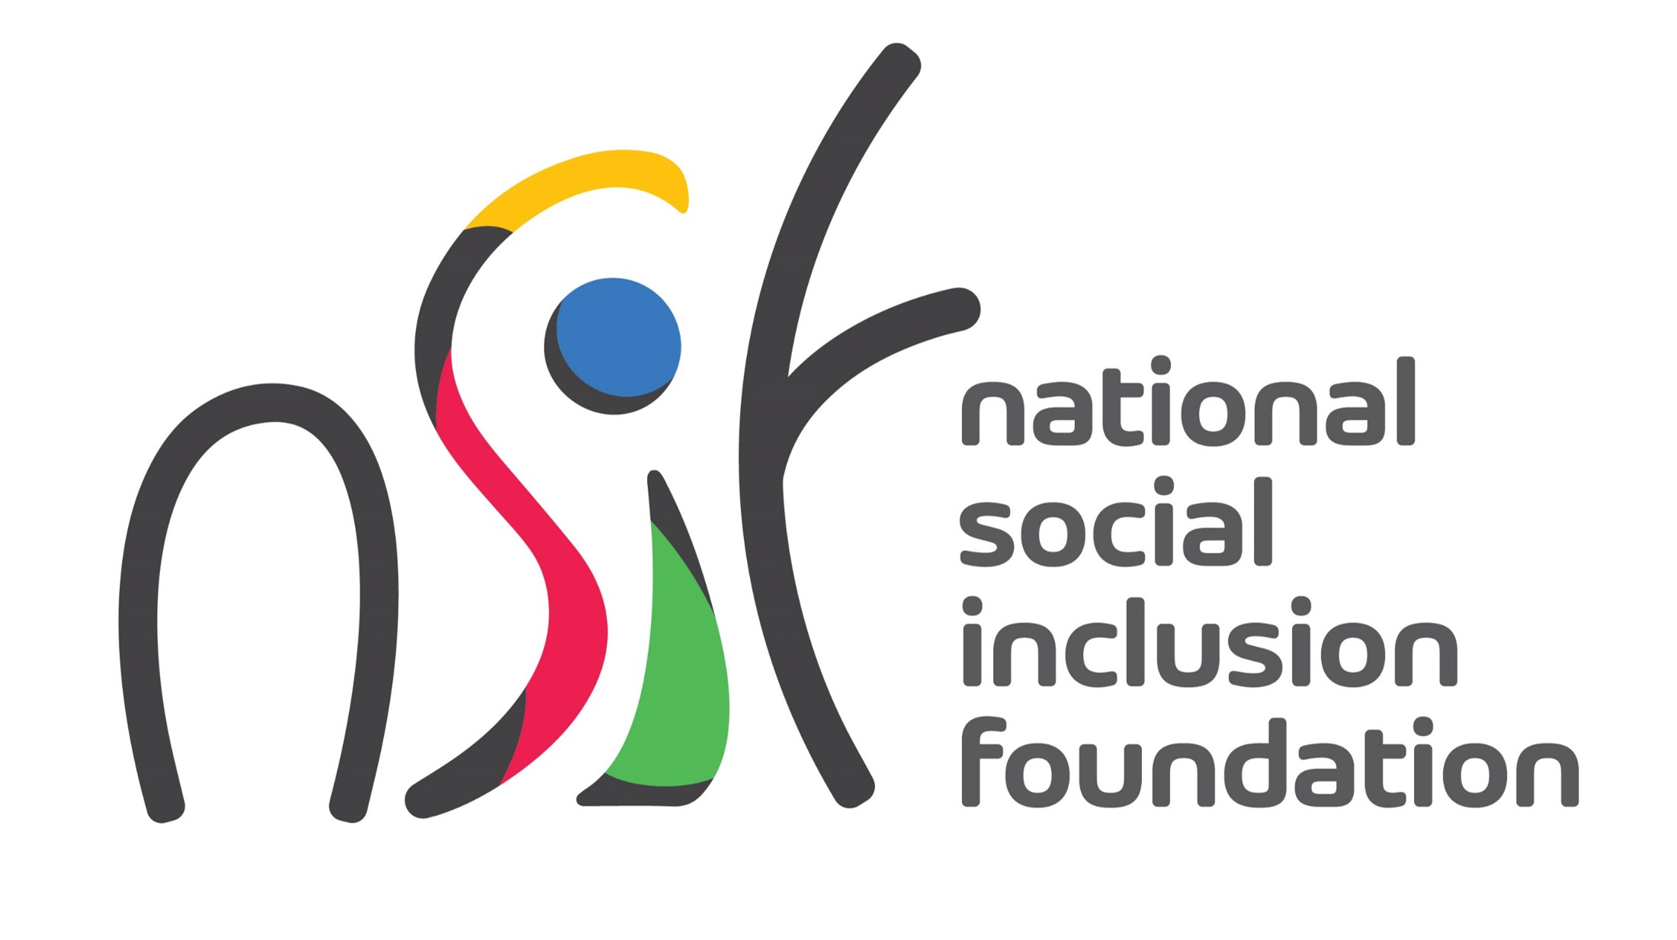

Call for Expression of Interest from
Residential Care Homes

National Programme on Reintegration of Stabilised Mental Patients of
the Brown Sequard Mental Health Care Centre (BSMHCC)

About the National Social Inclusion Foundation

The National Social Inclusion Foundation (NSIF) is the central body to receive and allocate public funds to NGOs. The Foundation operates under the aegis of the Ministry of Social Integration, Social Security and National Solidarity. Its mission is “to empower and improve the wellbeing of people living in conditions of poverty and vulnerability through impactful and sustainable stakeholder partnerships”.

National Programme on Reintegration of Stabilised Mental Patients of BSMHCC

The BSMHCC currently accommodates long stay, mental patients even though they are well stabilised and do not require hospitalisation. The patients are capable of carrying out their normal daily living activities but have been abandoned/neglected by their relatives.

The NSIF, in partnership with the BSMHCC, the Ministry Health and Wellness, and the Ministry of Social Integration, Social Security and National Solidarity, is implementing a National Programme to support the reintegration of long stay, stabilised mental patients of the BSMHCC.

The National Programme will cater for:
- Placement of stabilised mental patients in Residential Care Homes
- Medical follow-ups by mental health professionals from BSMHCC
- Facilitating engagement of the patients in social and leisure activities and re-establishing/maintaining contain with their family members

The Programme will be implemented through participating Residential Care Homes and NGOs.

Expression of Interest and Criteria for Selection

The NSIF invites Residential Care Homes willing to participate in the Programme to express their interest.

The following conditions shall apply for the selection of Homes into the Programme.
- The Home should be registered under the Residential Care Home Act
- It must be able to accommodate stabilised mental patients (up to a maximum of 10)
- It should provide the following services:
  - Appropriate care and residential services
  - Giving medication to patients as may be prescribed
  - Social and leisure activities, including outdoor activities in collaboration with NGOs
  - Conveyance of patients to hospital in case of emergency
- The Home must agree to work in collaboration with NGOs and provide access to NGO staff on premises for:
  - Follow ups of patients
  - Occupational therapy (twice monthly for a period of 12 months)
  - Psychological support (twice monthly for a period of 6 months)
- It must allow family members to visit patients
- It must have experienced staff to work with mentally ill patients
- It must agree for carers/staff to be given necessary training including on the job training
- It should submit regular feedback/reports on patients

Submission of Expression of Interest

Proposals should be submitted on the prescribed Expression of Interest Form and sent by email to applications@nsif.mu.

The Deadline for the submission of Expressions of Interest is Wednesday 31 May 2023.

For any further information and guidance, please contact the NSIF at info@nsif.mu or call on 2602406.

