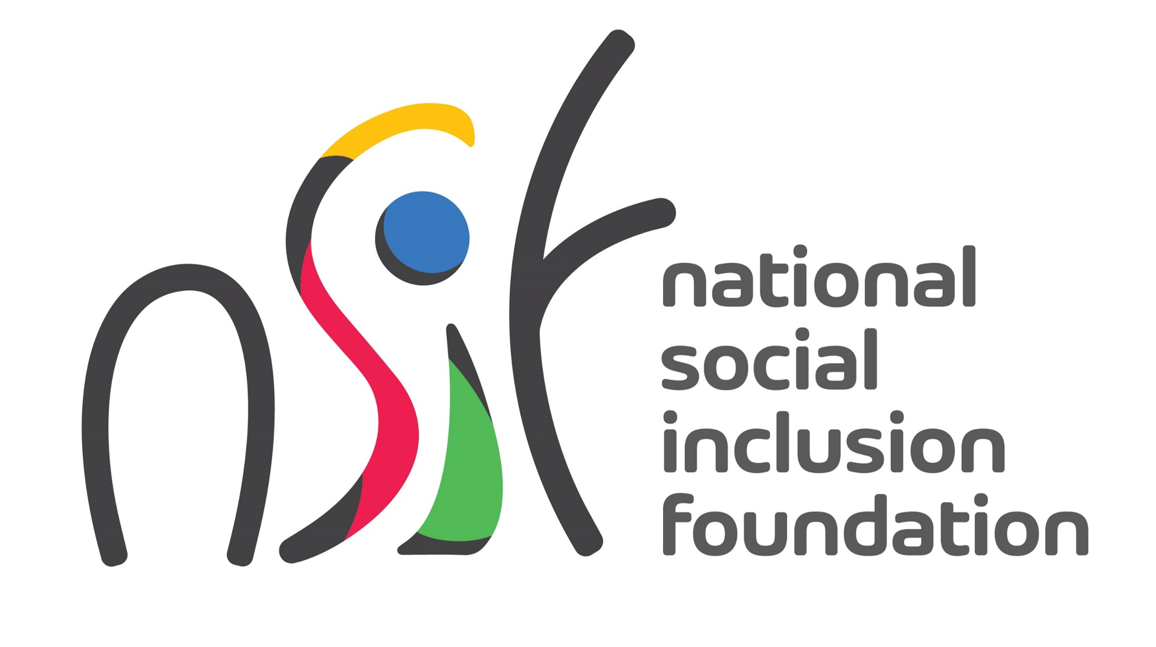

Call for Expression of Interest

Vulnerable Youth National Programme

The National Social Inclusion Foundation (NSIF) is the central body to receive and allocate public funds to NGOs. The Foundation operates under the aegis of the Ministry of Social Integration, Social Security and National Solidarity. Its mission is “to empower and improve the wellbeing of people living in conditions of poverty and vulnerability through impactful and sustainable stakeholder partnerships”.

Vulnerable Youth National Programme

Vulnerable and at-risk youths face various personal, social and economic challenges that hinder their potential for growth and to lead fulfilling lives while increasing their likelihood of engaging in harmful behaviours and experiencing negative life events. Vulnerable youths may be exposed to an array of struggles including low educational attainment, substance abuse, mental health issues, criminal involvement, poverty and homelessness.

As announced in the Budget Speech 2023-2024, the NSIF seeks to undertake a National Programme aimed at engaging vulnerable youths in a range of structured activities promoting their overall well-being and preventing risky behaviours. The National Programme will target 6,000 youths, providing them with physical, emotional, and social benefits and empower them to make positive choices and break the cycle of vulnerability.

The National Programme will adopt a multifaceted approach for providing effective support to vulnerable youths through diverse and holistic interventions promoting physical health, self-esteem and confidence, emotional wellbeing, positive social interactions, life skills and a sense of belonging and purpose.

Eligibility Criteria

The NSIF is looking to partner with an appropriate organisation able to act as principal recipient of funds and implementing agent for the Vulnerable Youth National Programme.

This Call is open to both governmental and non-governmental organisations having clear mandates and proven expertise and experience to work with youths at the national level.

They should demonstrate the technical capacity to implement and coordinate a diverse range of interventions, reaching out to 6,000 youths in schools and communities nationwide. They should also have adequate capacity to manage funds and human resources.

Submission of Expression of Interest

Interested applicants are invited to submit a comprehensive concept paper as per the following format.
  - Profile of organisation, including governance and management structures, technical staffing
  - Experience in working with youths, including programmes implemented
  - Strategy to reach out to 6,000 youths
  - Description of proposed interventions and implementation plans
  - Staffing, materials and logistics required
  - Indicative budget estimates

Concept papers should be sent by email to applications@nsif.mu

The Deadline for the submission of Expressions of Interest is Friday 29 September 2023.

For any further information and guidance, please contact the NSIF at info@nsif.mu or call on 2602406.

