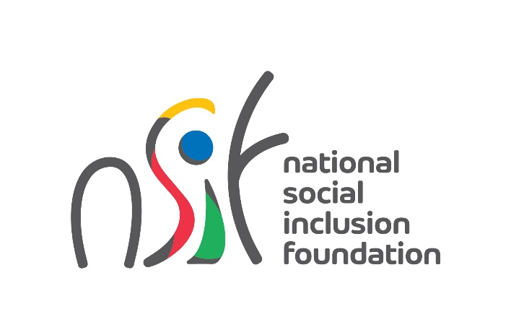

**Request for Proposals**

*Consultant to provide Public Relations (PR) and Event Management services*

**REF: NSIF/RFQ/04/2023**

**LETTER OF INVITATION**

Dear Sir/Madam,

Subject: *Consultant to provide Public Relations (PR) and Event Management services*

1. You are hereby invited to submit proposals for the provision of Public Relations (PR) and Event Management services to the *National Social Inclusion Foundation* which could form the basis for future negotiations and ultimately, a Contract between you and the *National Social Inclusion Foundation* .
2. The purpose of this assignment is to develop and execute an effective promotion campaign to encourage volunteering across diverse segments of the population, culminating in the successful organisation of a main event on the International Day for Volunteers celebrated on 5 December 2023.
3. The following documents are enclosed to enable you to submit your proposal:
4. The Terms of Reference (TOR) Annex 1
5. Price Activity Schedule Annex 2
6. Any request for clarification should be forwarded via e-mail (info@nsif.mu) addressed to the same person mentioned in para. 5. Request for clarifications should be received 10 days prior to the deadline set for submission of proposals in para. 5.
7. Submission of Proposals

The proposals should reach the National Social Inclusion Foundation (NSIF) by **1300 hours Monday 18th September 2023** at the following address:

The Secretary General,

National Social Inclusion Foundation,

Level 6, Garden Tower, Poudriere Street,

Port Louis.

Proposals should **not** be forwarded by electronic mail.

1. Deciding Award of Contract

Qualification and experience of the *Consultants* shall be considered as the paramount requirement. Proposers must have a minimum of three (3) years of experience in providing services similar to those requested in this Request for Proposals.

The proposal will be evaluated on the basis of a maximum of 70 marks for Technical proposals and 30 marks for Financial proposals. Proposals from consultants should score at least 50 marks for the Technical Proposals to be retained for further consideration.

The duration of the Contract shall be for a period of 3 months starting as from the date of the signature of the Contract agreement.

1. Documents to be submitted

(a) Brief that illustrates expertise and experience in the field

(b) Detailed resumés of key staff to be involved in this assignment with an outline of relevant past/present experience, including experience of similar nature in public/private institutions

(c) Supporting documents of key staff (NID card, certificates)

(d) List of current and former clients with details

(e) Three reference letters

(f) VAT& BRN Registration Certificate

(g) Any other relevant documents

(h) Annexure 2 – Price Activity Schedule

1. Please note that the *National Social Inclusion Foundation* is not bound to select any of the Consultants submitting proposals.

1. You are requested to hold your proposal valid for 60 days from the deadline for submission of proposals during which period you will maintain without change, your proposed price. The National Social InclusionFoundation will make its best efforts to finalize the agreement within this period.
2. Please note that the cost of preparing a proposal and of negotiating a Contract is not reimbursable as a direct cost of the assignment.
3. Please note that the remuneration which you receive from this contract will be subject to normal tax liability in Mauritius.
4. We commit ourselves to maintain the highest standard of integrity and ethical principles during all stages of the procurement cycle.
5. The *National Social Inclusion Foundation* would like to thank you for considering this Request for Proposals.

Yours faithfully,

**(Sowdagur A)**

**Secretary General**

**Enclosures:**

Annexure 1: Terms of Reference

Annexure 2: Price Activity Schedule

**Annexure 1**

**TERMS OF REFERENCE**

1. **Background**

The National Social Inclusion Foundation (NSIF) is the central body for receiving and allocating public funds to NGOs. It operates under the aegis of the Ministry of Social Integration, Social Security and National Solidarity. The mission of the Foundation is ‘to empower and improve the wellbeing of people living in conditions of poverty and vulnerability through impactful and sustainable stakeholder partnerships’.

To mark the International Day for Volunteers, the NSIF aims to promote volunteering across diverse segments of the population. The Foundation intends to launch a comprehensive promotion campaign and organise a main event on 5 December 2023.

1. **Objective**

The NSIF is seeking to engage a qualified and experienced consultant to provide Public Relations (PR) and Event Management services. The primary objective is to develop and execute an effective promotion campaign to encourage volunteering among citizens from various backgrounds, culminating in the successful organisation of a main event on the International Day for Volunteers.

**3. Scope of Work:**

The consultant's responsibilities will include but are not limited to:

Promotion Campaign:

* Develop a strategic PR plan outlining campaign objectives, target audiences, key messages, and communication channels.
* Create engaging content (press releases, social media posts, articles) to raise awareness about volunteering and the International Day for Volunteers.
* Collaborate with media outlets, influencers, and stakeholders to secure media coverage and feature stories.
* Monitor and analyze the effectiveness of the promotion campaign, making necessary adjustments to maximize impact.

Event Management:

* Design a comprehensive event plan covering logistics, program schedule, guest list, and technical requirements.
* Coordinate with suppliers, and partners to ensure smooth event execution.
* Manage event registration and attendance tracking.
* Liaise with the media to ensure coverage of the event.
* Handle post-event activities, including feedback collection and reporting on the event's success.

**4. Consultant Qualifications:**

The selected consultant should possess the following qualifications:

* Proven experience in PR and event management, preferably with a track record of executing successful public engagement campaigns.
* Demonstrated understanding of volunteerism and social engagement initiatives.
* Strong communication skills, both written and verbal, to effectively convey the importance of volunteering to diverse audiences.
* Creative thinking and the ability to develop innovative ideas for promotion and event engagement.
* Established network within media, influencer, and community circles.
* Experience in managing diverse stakeholders, including government agencies and non-governmental organizations.
* Ability to work within budget constraints and adhere to timelines.

**5. Deliverables:**

The consultant is expected to deliver the following:

* A detailed PR plan outlining campaign strategies and tactics.
* Engaging and impactful content for various communication channels.
* A comprehensive event plan encompassing logistics, schedule, and program elements.
* Successful execution of the International Day for Volunteers event on 5 December 2023.
* Post-event report evaluating the effectiveness of the campaign and event, including attendance, media coverage, and participant feedback.

**6. Selection Criteria:**

Consultants will be evaluated based on the following criteria:

* Relevance of prior experience in PR and event management for public engagement campaigns.
* Understanding of volunteerism and its promotion in a diverse societal context.
* Creativity and innovation in developing campaign strategies and event concepts.
* Demonstrated network and connections within relevant media and community circles.
* Proposed approach to engaging stakeholders and ensuring successful event execution.
* Proposed costing for the consultancy services.

**7. Submission of Proposals:**

Interested consultants are requested to submit their detailed proposals, including a cover letter, CV, portfolio of relevant work, proposed strategies and a costing to the address below by **1300 hours** **18th September 2023.**

The Secretary General,

National Social Inclusion Foundation,

Level 6, Garden Tower, La Poudrière Street,

Port Louis.

Proposals should **not** be forwarded by electronic mail.

Note: NSIF reserves the right to reject any or all proposals received and to terminate the selection process at any stage without assigning any reason whatsoever. The final terms of engagement will be negotiated with the selected consultant.

**PAYMENT**

Payment shall be made after the assignment and upon submission of a claim.

**Annexure 2**

**PRICE ACTIVITY SCHEDULE**

|  |  |  |  |
| --- | --- | --- | --- |
| **Item No** | **Description** | | **Total Price**  **(Rs)** |
| (i) |  | |  |
| (ii) |  | |  |
| (iii) |  | |  |
| (iv) |  | |  |
|  |  | **Subtotal** |  |
|  |  | **VAT @ %** |  |
|  |  | **Total** |  |