Guidelines on Duty Free Scheme for NGOs

Non-Governmental Organisations (NGOs) registered with the National Social Inclusion Foundation (NSIF) are eligible for customs and excise duty exemption on the purchase of a vehicle.

Eligibility Criteria

The organisation should be:
- Duly registered with the NSIF.
- A regular service provider warranting the use of a vehicle.
- Fully compliant with the statutory obligations of its regulatory body (e.g. Registrar of Associations, Registrar of Companies).

The NSIF reserves the right to carry out further due diligence and/or seek additional information prior to the approval of the application.

Types of Vehicles

NGOs may avail of customs and excise duty exemption on the purchase of the following types of vehicles.
- One motor vehicle for the transport of ten or more persons, including the driver, e.g. a bus;
- One motor car of an engine capacity not exceeding 1,600 c.c.;
- One double space cabin vehicle;
- One single space cabin vehicle; or
- One van.

Conditions

- NGOs shall benefit from duty exemption on the purchase of one motor vehicle subject to approval by the NSIF.
- This exemption shall be granted not more than once in every 7 years.
- Exemption for a replacement motor vehicle may be granted before the 7 years where the motor vehicle is damaged in an accident and is duly certified a total loss.
- The use of the vehicle should be for the sole purpose of conveyance of beneficiaries, staff, volunteers and/or equipment/materials on a regular basis in furtherance of the objects of the organisation.

Documents to be Produced

- Completed Application Form.
- Certified/audited financial statements for the last two years.
- A list of current members of its governing body.
- Where the organisation is not funded by the NSIF, a report on activities for the last two years.
- Quotation of the vehicle to be purchased.

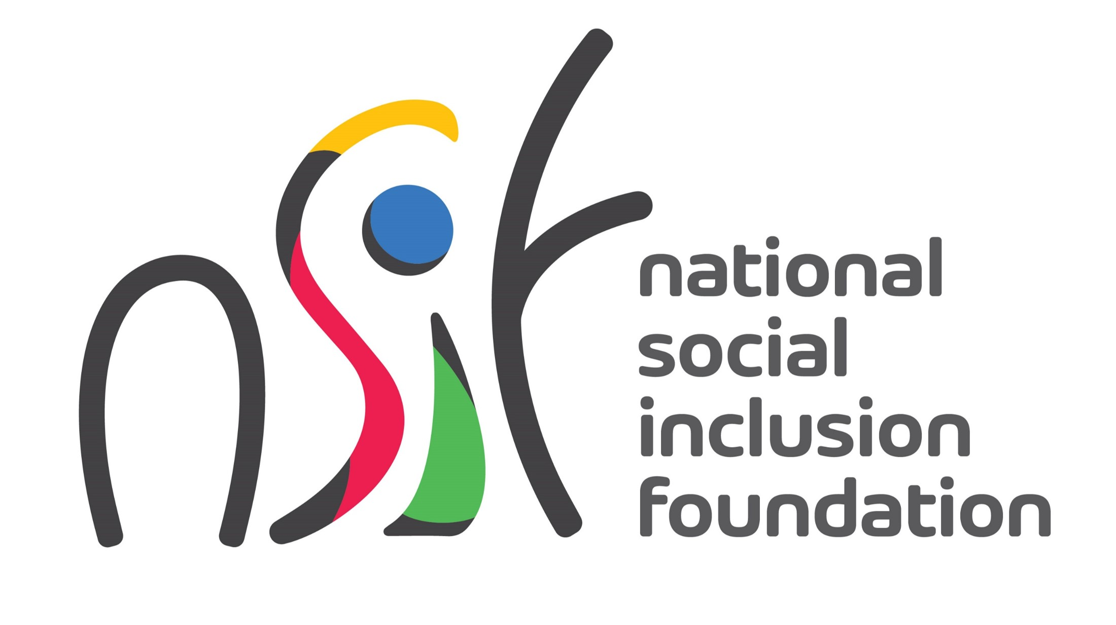

APPLICATION FORM FOR CUSTOMS AND EXCISE DUTY EXEMPTION ON PURCHASE OF A MOTOR VEHICLE

Part A: Details of Organisation
Name of Organisation
Address
Email
Telephone
NSIF Registration No.
Objects of Organisation
Core Services
Profile of Beneficiaries
Number of Beneficiaries
Locality where Services are Delivered

Part B: Details of Applicant
Name of Applicant
Designation
Address
Email
Telephone
Part C: Type of Vehicle
One motor vehicle for the transport of ten or more persons, including the driver, e.g. a bus; | ☐
One motor car of an engine capacity not exceeding 1,600 c.c. | ☐
One double space cabin vehicle | ☐
One single space cabin vehicle | ☐
One van | ☐
Part D: Other Information
Purpose for which vehicle is to be used
Sources of funds for financing purchase of vehicle
Date when returns were last filed to the Regulatory Body

Part D: Declaration
I, ………………………………………………………………………... (Full Name in BLOCK LETTERS), do hereby declare that:
- The application for customs and excise duty exemption on purchase of a motor vehicle has been approved by the Managing Committee/Board of the organisation, and
- The information in this Form is true and correct.

Signature:

Date:
Part E: For Office Use Only (Not to be filled by applicant)
The organisation: | Yes | No
- Meets the eligibility criteria
- Has submitted all relevant documents
The application for duty exemption is approved/not approved.

Name:
Position:
Date:

